Enhanced Entity Relationship Diagram

System: Web based Vehicle Rental System

Group ID: Pro_I_46  
Course: IT2140 – Database Design & Development Semester: Y2S1 (2025)

**1. System Purpose**

The aim of the system is to allow customers to browse vehicles, make bookings, perform secure payments, and write reviews, while staff manage vehicles and branches. The EER diagram defines the data foundation for this system.

**. Users**

1. **Customer** – registers, books vehicles, makes payments, writes reviews.
2. **Staff** – manages vehicles and branch details, oversees bookings.
3. **Branch Manager** – responsible for a specific branch.
4. **Admin** – handles overall system administration.

**3. Functional Requirements**

* User registration/login with profile info (composite address, phone).
* Customers create **Booking** for a **Vehicle** with pickup date/time.
* Prevent double-booking, enforce availability.
* Customers complete **Payment** with method, amount, status.
* Customers write **Review** with rating/comment after bookings.
* Staff manage vehicles and branches.
* Reports: daily bookings, payments, top-rated vehicles.
* Audit logs for staff actions

**4. Non-Functional Requirements**

* **Security**: password hashing, role-based access.
* **Reliability**: ACID transactions for booking & payment.
* **Performance**: search results in <2s.
* **Scalability**: support multi-branch and 100k+ bookings.
* **Usability**: simple booking flow, accessible forms.
* **Data Quality**: mandatory PKs, FKs, field validations.
* **Backup/Recovery**: nightly backups, recovery for payments.

**5. Constraints / Assumptions**

* One booking = one vehicle; vehicle may have many bookings.
* One payment belongs to one booking.
* Review is linked to one booking/vehicle.
* Each branch is managed by one staff (branch manager).
* Branch phone numbers are multivalued.
* Age is derived from DOB.

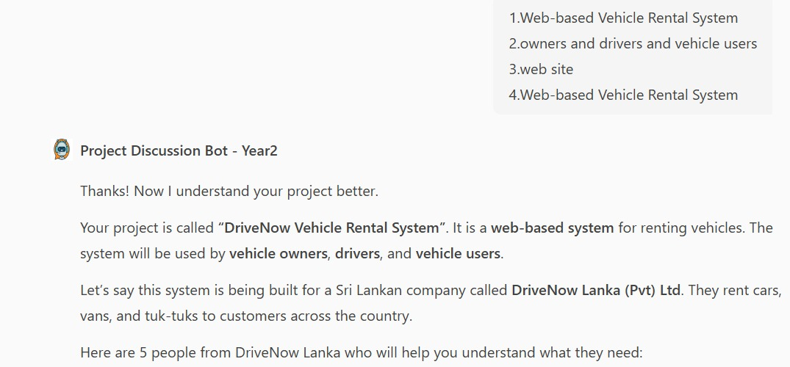6. Requirement-Gathering Evidence



